Function pattern Example 1

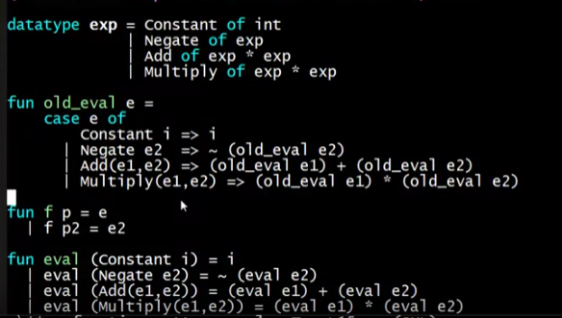

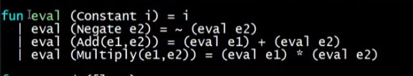

* But it’s just syntactic sugar of this old_eval:

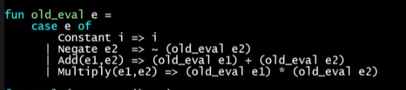

Another example:



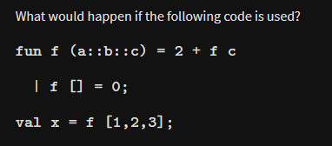

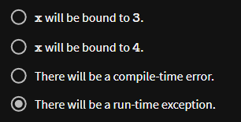

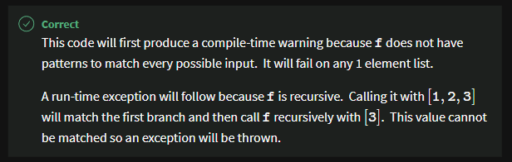

* This is the reason why function patterns are not really preferrable
  + We use case expressions

